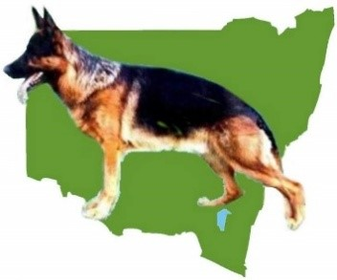

GERMAN SHEPHERD DOG LEAGUE OF NSW INC
Members Competition
The Bill Spilstead Complex for Canine Affairs
44 Luddenham Rd, Orchard Hills (GSD Grounds)

6TH December 2025

Judging commences at 6.00pm

CHANGE OF JUDGE TO IAN URIE

Classes to be judged: All Long stock bitches followed by stock coat bitches, all long stock dogs followed by all stock coat dogs.

ENTRIES CLOSE – 29th November 2025

PH & Extreme Weather :0417414285
Cheques Payable to: German Shepherd Dog League Inc

Judging commences at 6.00pm

Initial Entry: $30.00 (Includes Catalogue) $28.00 subsequent entries
Point Score: GSDL Catalogue: $5.00

Conformation: Excellent Medallions may be awarded to animals 2 years and over, entered in the Open Class and having been
successfully breed surveyed . Gun test may be used in Open Class at Judges Discretion

Prizes
Trophy & Sash to Best Dog & Bitch, Runner-up Dog & Bitch and
all class winners.

Please see the website for Christmas Presentation prior to the Show

ON LINE ENTRIES TO



PAPER ENTRIE TO: PO Box 78, Waterford West, QLD 4133
NO LATE ENTRIES WILL BE RECEIVED

